Assignment 1  
The final screenshot of the report view page which appears when power desktop starts:

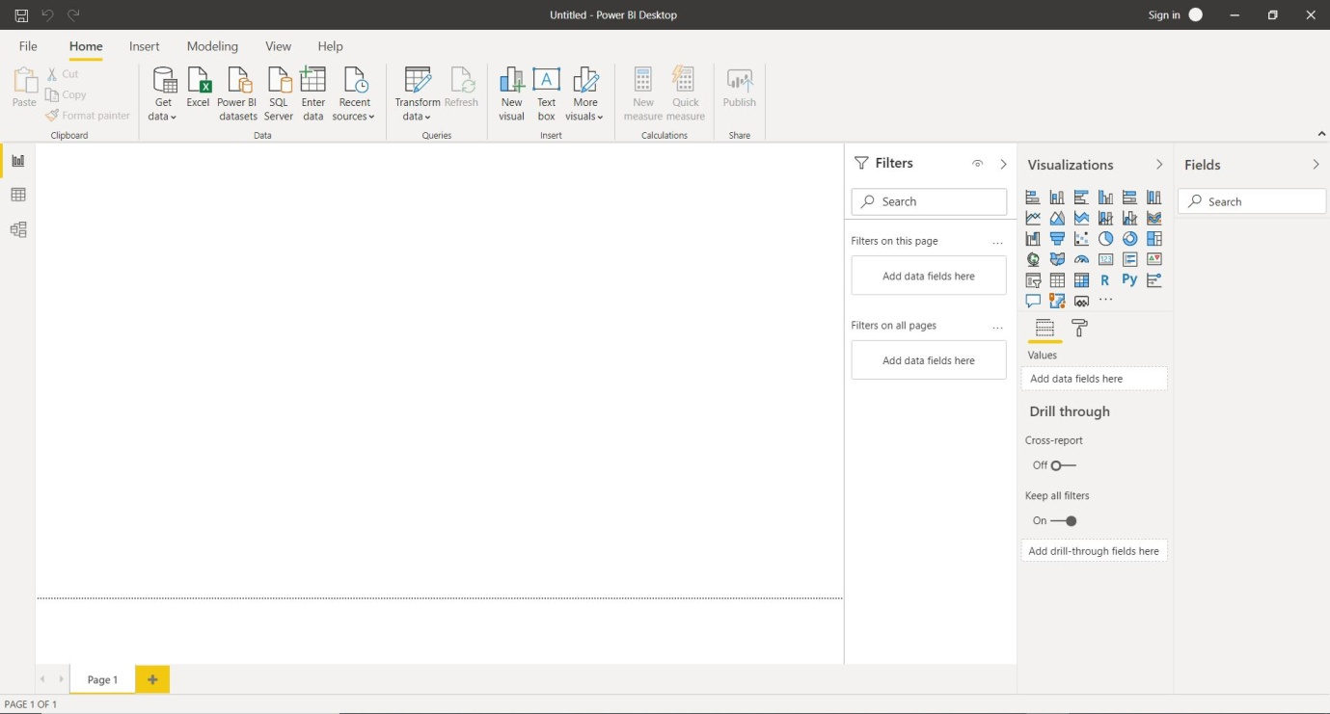

Report View:



Data View:

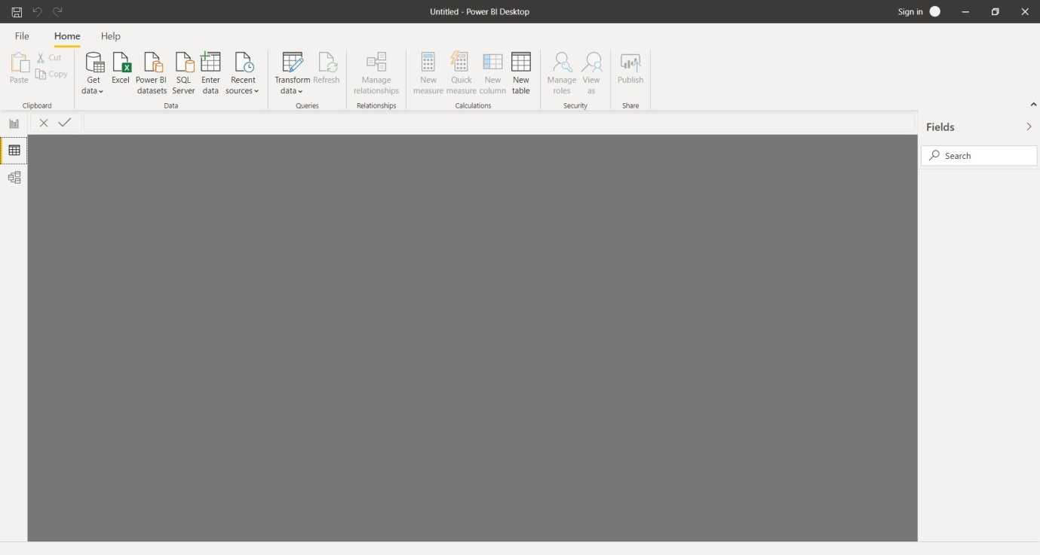

Model View:

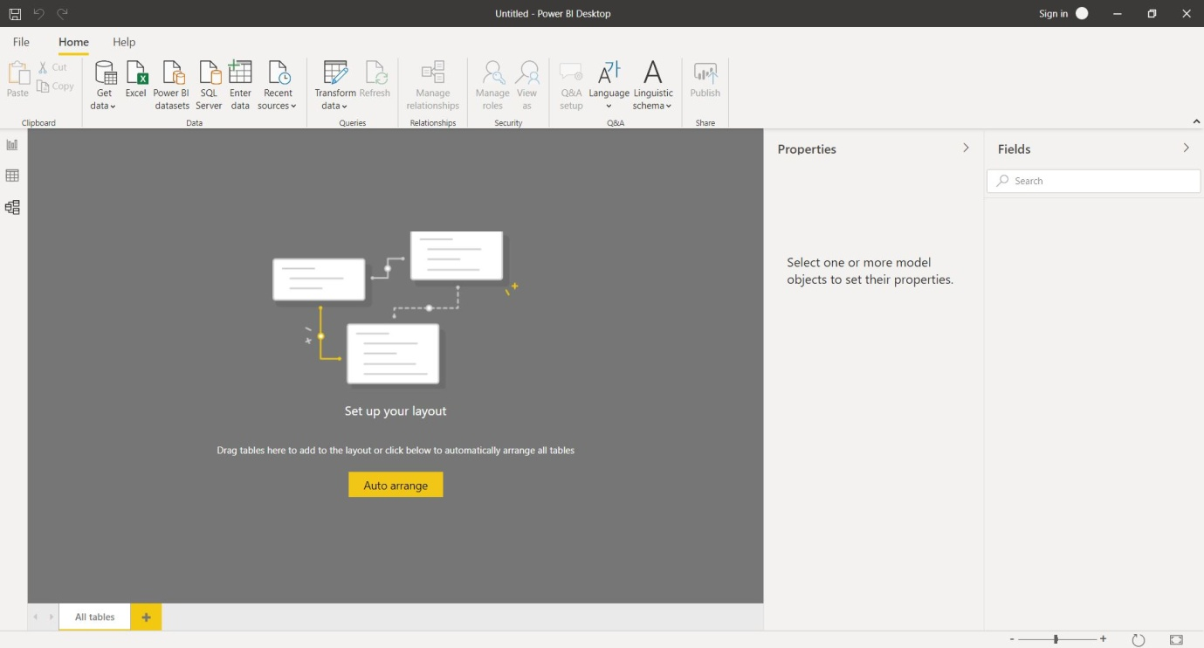

Power Query Editor:

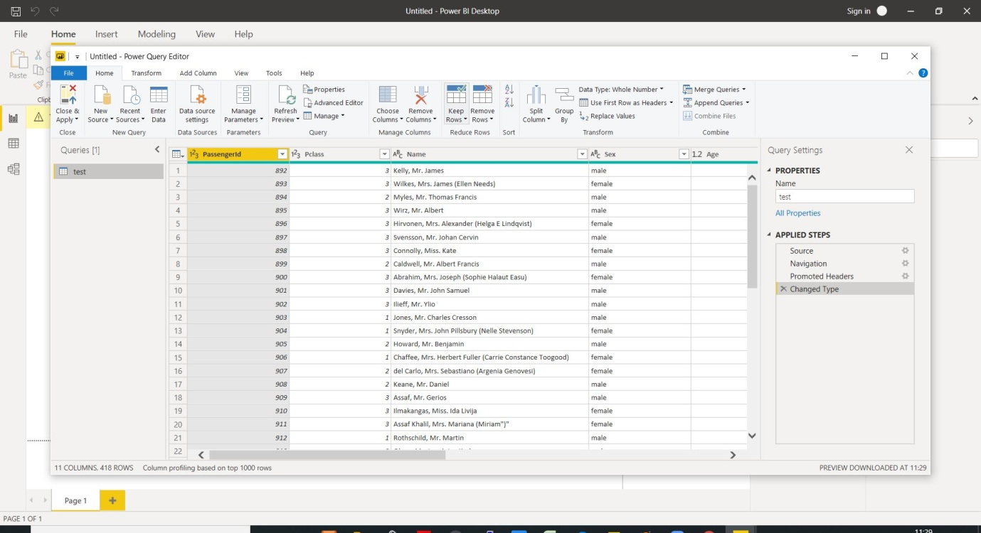

Advance Editor:

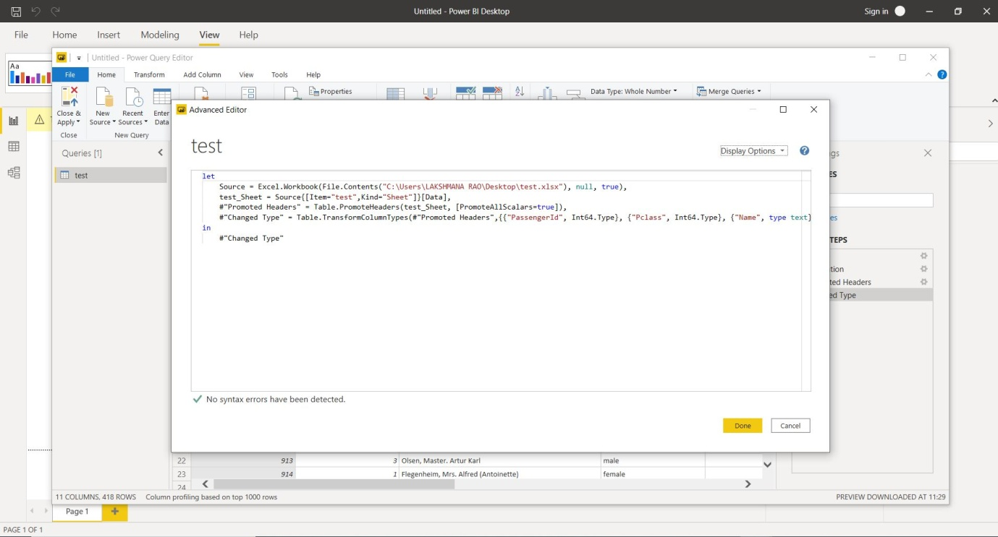

Details with there price:

## Power BI Desktop:

Power BI Desktop is a free application you install on your local computer that lets you connect to, transform, and visualize your data. With Power BI Desktop,one can connect to multiple different sources of data, and combine them (often called modeling) into a data model. This data model lets you build visuals, and collections of visuals you can share as reports, with other people inside your organization. Most users who work on business intelligence projects use Power BI Desktop to create reports, and then use the Power BI service to share their reports with others.

The most common uses for Power BI Desktop are as follows:

-Connect to data

-Transform and clean that data, to create a data model

-Create visuals, such as charts or graphs, that provide visual representations of the data

-Create reports that are collections of visuals, on one or more report pages

-Share reports with others by using the Power BI service

-People most often responsible for such tasks are often considered data analysts (sometimes referred to as analysts) or business intelligence professionals (often referred to as report creators).

## Pricing:

**Power BI** comes in three levels – Desktop, Pro, and Premium.

The Desktop level **is** free for individual users.

Pro plan **costs** $9.99 per user per month.

Premium plan starts at $4,995 a month per dedicated cloud compute and storage resource.